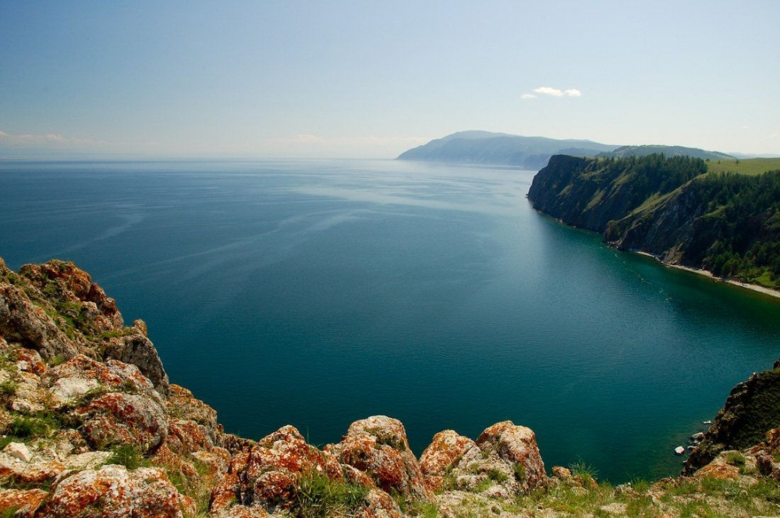
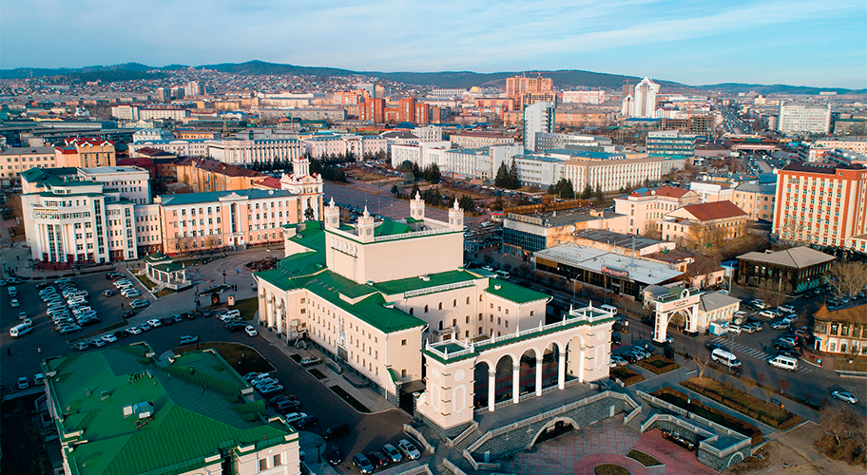
Course overview FOR FOREIGN STUDENTS AT BURYAT STATE UNUVERSITY 2022-2023

ПОДЗАГОЛОВОК МЕРОПРИЯТИЯ
-------------------------------------
ДАТА
ВРЕМЯ
МЕСТО ПРОВЕДЕНИЯ
Адрес, город, почтовый индекс

Department | Name of a course/ content / language | Duration of a course | Price | Document | Learning Online
Russian as foreign language Department | Course “Russian as a foreign language” / primary pre-University education / Russian | 1 year / 612 hours | ₽ 70 000 a year  Free if exchange program | Certificate | Possible
 | Course “Russian as a foreign language + 2 subjects” /primary pre-University education / Russian | 1 year /620 hours | ₽ 75 000 a year | Certificate | Possible
 | Master's program "Russian as a Foreign Language / Russian | 2 years | ₽ 96 600 a year | Diploma | -
 | Course “Advanced training course for foreign teachers of the Russian language” /Russian | 36 hours | For group 10-14 people - ₽ 3000  For group 15 and more people - ₽ 2500 | Certificate | Possible
 | Preparation for testing (A1-C1 Levels) / Russian | 1 semester | ₽ 30 000 a semester | Certificate | Possible
Institute of Oriental Studies | Course “Mongolian for foreigners” / Modern Mongolian language, old-writing Mongolian, regional studies, colloquial Mongolian/ Russian and Mongolian | 1 year / 288 hours | ₽ 75 000 a year | Certificate | -
 | Tourism / Marketing in tourism, Law regulation in Tourism, Standards and Certification in Tourism, Technologies of touristic service, Technologies of excursion/route services / Russian | 1 semester/ 500 hours | ₽ 45 150 a semester  Free if exchange program | Academic transcript | -

