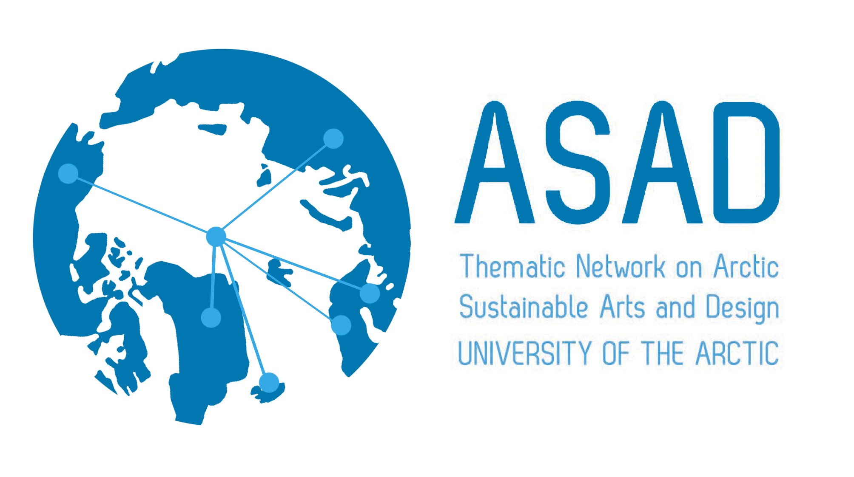
Relate North 2015
Culture, Community & Communication

SYMPOSIUM & EXHIBITION
CALL FOR CONTRIBUTIONS

You are invited to submit artworks and/or an abstract for the art exhibition and symposium RELATE NORTH 2015. The symposium and exhibition is a collaboration between the University of the Arctic, ASAD thematic network, the University of Alaska Anchorage, the University of Lapland and the Kimura Gallery.

Arctic Sustainable Arts and Design (ASAD) is a Thematic Network that aims to identify and share contemporary and innovative practices in teaching, learning, research and knowledge exchange in the fields of arts, design and visual culture education. In summary, the network seeks to promote cooperation and collaboration between academic institutions and communities, advance art education amongst members and share both traditional and contemporary practices in teaching, learning and research.

Symposium and exhibition theme: What role can art play in representing a northern sense of culture, community and identity? How can art stimulate debate about indigenous issues and other northern and Arctic ways of living in challenging environments? What role can art play in communication of northern issues? How might art communicate some of the challenges facing those living in northern areas today? What role might art play in chronicling issues important to places and people in the north? These questions are central to this long-term project coordinated by ASAD.

The call is open to media in contemporary art and presentations of community-based art, environmental art or art education projects.

DATES
Symposium: November 4-6, 2015
Post Symposium Excursion: November 7, 2015
Exhibition: November 6-December 4, 2015
Exhibit Opening Reception: Nov 6, 2-4pm, Kimura Gallery

VENUE
University of Alaska Anchorage, the Fine Arts Building and the Kimura Gallery
http://www.uaa.alaska.edu/art/

SELECTION CRITERIA
Artworks or abstracts are sought that:
- Explore and investigate northern or arctic issues through art
- Use traditional or contemporary aesthetic practices to communicate insights, offer representations of northern cultures and communities
- Seek to develop and engage people in issues connected with the North

DEADLINES
- Submission of proposed artworks or abstracts by July 3, 2015
- Successful contributors will be notified by July 30, 2015
- Detailed information about exhibition venues and conditions by September 15, 2015

DELIVERY AND RETURN OF ARTWORKS
Artists are responsible for the delivery and return of their own artworks.

ORGANIZING COMMITTEE
- Timo Jokela, Professor of Art Education, Dean of the Faculty of Art& Design, University of Lapland. Chair of Thematic Network of Arctic Sustainable Arts & Design.
- Herminia Din, Professor of Art Education, Department of Art, UAA
- Glen Coutts, Professor of Applied Visual Arts, Faculty of Art and Design, University of Lapland
- Sean Licka, Professor of Art History, Department of Art, UAA
- Steve Godfrey, Associate Professor of Ceramics and Chair, Department of Art, UAA
- Maria Williams, Director, Alaska Native Studies, UAA

CURATORS OF THE EXHIBITION
- Sean Licka, Steve Godfrey, and Herminia Din

Please complete and return the following CONTRIBUTOR APPLICATION FORM by e-mail to Herminia Din (hdin@uaa.alaska.edu) no later than June 15, 2015.

Please choose either symposium abstract or artwork for exhibition, or both.

CONTRIBUTOR APPLICATION FORM

BIOGRAPHY
- Authors/artists (list the names of all authors/artists including yourself if you are the author/artist in the order in which you wish them to appear in the printed text.)
- Short biography, please include affiliations, contact details including email, and/or website (maximum 100 words)

EXHIBITION
- Please list title, technique, medium, year, and size of the proposed artwork
- Limit to 1 or 2 small/medium size artworks, or educational projects
- Artist’s Statement (please explain in no more than 150 words how the work meets the criteria.) Please note this statement is vital and will be used in the exhibition catalogue. If the artist’s statement is missing, the applications will not be considered.
- A clear description of space and devices needed for showing the artwork
- Please attach max three (3) photos of the proposed artwork. Artwork photos must be print quality, as they will be used for the exhibition catalogue (resolution 300 dpi, jpg format, file size max 8Mb). If artists do not supply images at high resolution, the organizers reserve the right to decline the submission.

SYMPOSIUM
- Please provide a title (up to 10 words) and an abstract (no more than 150 words) of your presentation

Information about registration will be posted on the ASAD web pages at the beginning of June: http://www.asadnetwork.org

